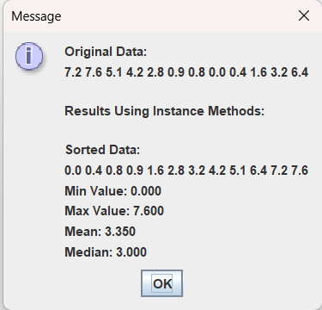
package as04;
import java.util.Arrays;

public class Statistics {
private double[] data;
private double[] sdata;
public static int count = 0;

public Statistics(double[] idata){
data = idata.clone();
sdata = new double[data.length];
count++;
}

public double[] getOrigData(){
return data;
}

public double[] getSortedData(){
sdata = data.clone();
Arrays.sort(sdata);
return sdata;
}

public double findMin(){
double min = sdata[0];
for(double x : sdata){
if(x < min){
min = x;
}
}
return min;
}

public double findMax(){
double max = sdata[0];
for(double x : sdata){
if(x > max){
max = x;
}
}
return max;
}

public double findMean(){
double total = 0.0;
double count = sdata.length;
for(double x : sdata){
total += x;
}
return total/count;
}

public double findMedian(){
int index = 0;
if (sdata.length % 2 != 0){
index = sdata.length/2;
return sdata[index];
}
else{
int mid = sdata.length/2;
return (sdata[mid]+sdata[mid-1])/2;
}
}

public static double[] computeSortedData(double[] data){
return (new Statistics(data)).getSortedData();
}

public static double computeMin(double[] data){
Statistics s = new Statistics(data);
s.sdata = s.getSortedData();
return s.findMin();
}

public static double computeMax(double[] data){
Statistics s = new Statistics(data);
s.sdata = s.getSortedData();
return s.findMax();
}

public static double computeMean(double[] data){
Statistics s = new Statistics(data);
s.sdata = s.getSortedData();
return s.findMean();
}

public static double computeMedian(double[] data){
Statistics s = new Statistics(data);
s.sdata = s.getSortedData();
return s.findMedian();
}
}

